Name: _Ann-Marie Mignone________

Date: ___9th February 2021______________________

**GOAL: LEARN HOW TO CREATE GOOD SPREADSHEETS!**

**Purpose:**

1. **What is a spreadsheet and how do they work**
2. **What separates a good dataset from a bad one**
3. **How can we apply best practices to create a spreadsheet that is useful to other**

What is clean data? Clean data are in a format that is ready to analyze. Characteristics of clean data include data that are:

Common symptoms of messy data include data that contain:

* Special characters (e.g. commas in numeric values)
* Numeric values stored as text/character data types
* Duplicate rows
* White space
* Missing data
* Zeros instead of null values
* “highlights” and colors used to denote information
* More than one type of info stored in a cell

# Part A: For each spreadsheet identify at least one thing that makes it problematic. Then describe how you might go about fixing it (i.e., what could you do to make it ‘clean.’

**For help see:** [**https://datacarpentry.org/spreadsheets-socialsci/02-common-mistakes/index.html**](https://datacarpentry.org/spreadsheets-socialsci/02-common-mistakes/index.html) **or watch the online video I filmed and put on AsULearn for Week 4**

1. **Sheet 1**

|  |  |  |  |
| --- | --- | --- | --- |
|  |  |  |  |
| **Sample** | **Date excavated** | **Date analyzed** | **Element** |
| **1** | **5/9/2019** | **1/5/20** | **Radius** |
| **2** | **5/1/2019** | **1/5/20** | **Radius** |
| **3** | **5/3/2019** | **1/6/20** | **Ulna** |
| **4** | **W** | **1/6** | **femur** |

**Problem: row four is messed up. DA:4 just says 1 / 6 and thus is missing the year. DE:4 just has a w and no date.**

**Better version: add the appropriate year to DA:4 and then either add the date to DE:4 or leave blank so the program can label it as unknown.**

1. **Sheet 2**

|  |  |  |  |  |  |
| --- | --- | --- | --- | --- | --- |
|  | Pit A |  | Pit B |  |  |
|  |  |  |  |  |  |
| Munsell | weight | Date | Munsell | weight | Date |
| 10 yr 4/3 | 1.5 | 2020-02-03 | 10 yr 2/3 | 7.5 | 2020-02-05 |
| 10 yr 4/3 | 1.7 |  | 10 yr 2/3 | 3 |  |
| 10 yr 4/3 | 2.0 |  | 10 yr 2/3 |  |  |
| 10 yr 4/3 | 2.1 | 2020-02-04 | 10 yr 2/3 | 3.3 |  |
| 10 yr 4/4 | 2 |  | 10 yr 2/3 | 9 |  |

**Problem: “two table” are used. This can create a major issues for programs as they will incorrectly read the tables as one. some integers are wrong (like the 2) and the dates are oddly formatted.**

**Better version: Instead of creating several columns for both pit and pit b, consolidate the duplicate columns (like date) into one column each, Then make a column for “pit” and label each rom as either a or b. Also specifically change the singular “2” to “2.0” to match the other numbers and make it easier for programs to read. The dates all need to be formatted the same as well.**

1. **Sheet 3**

|  |  |  |  |  |  |  |
| --- | --- | --- | --- | --- | --- | --- |
|  |  |  |  |  |  |  |
|  |  | Site | elements | Biological sex | Analysist |  |
|  | Skeleton UW-503 |  |  |  |  |  |
| Transect A |  | Oblion | Pelvis | Male | GP |  |
|  |  |  | femur | male | GP |  |
|  |  |  |  |  |  |  |
|  |  |  |  |  |  |  |
|  |  |  |  |  |  |  |
|  | Skeleton UW-504 |  |  |  |  |  |
| Transect B |  | PineTree | Cranium | Female | SL |  |
|  |  |  | Pelvis | Female | SL |  |
|  |  |  | Tibia | NA | SL |  |
|  |  |  |  |  |  |  |
|  |  |  |  |  |  |  |

**Problem: items in columns vs rows are a little incorrect. There is a use of “na” and capitalization is not consistent.**

**Better version: Perhaps make transect A and transect B as columns while making the skeleton items as rows. Keep character capitalization consistent. Also avoid use of “na”, leaving the space blank implies its unknown.**

1. **Sheet 4**

|  |  |  |  |  |  |  |  |  |
| --- | --- | --- | --- | --- | --- | --- | --- | --- |
|  |  | Week 1 |  | Week 2 |  | Week 3 |  |  |
| ID | SEX | date | weight | date | weight | Date | weight |  |
| 002 | M |  |  |  |  |  |  |  |
| 005 | F |  |  |  |  |  |  |  |
| 006 | F |  |  |  |  |  |  |  |
| 010 | M |  |  |  |  |  |  |  |
| 012 | M |  |  |  |  |  |  |  |
| 015 | M |  |  |  |  |  |  |  |

**Problem: repeats of columns and incorrect “stacking” of titles can lead to confusion**

**Better version: Perhaps consolidate columns to under one column of “weight” and the have week 1, 2, and 3 lablled inside this grouping.**

1. **Sheet 5**

|  |  |  |
| --- | --- | --- |
| Sample | date | Glucose level |
| 101 | 2019-01-14 | 150.5 |
| 102 | 2019-01-14 | 93.6 |
| 103 | 2019-01-14 | 99.5 |
| 104 | 2019-01-15 | 108.0 |
| 105 | 2019-01-15 | 7.9 |
| 106 | 2019-01-15 | 102.7 |

**Problem:** Is sample 105’s glucose level typed wrong or out of range? This one is actually hard for me to determine what is wrong. Is it a trick question? Is nothing wrong?

**Better version: Lock sample row? fixed GL:105?**

# Part B: fixing/data cleaning examples

Sadly, most folks don’t follow the above suggestions. Here is an example, modified from a colleague’s assignment, that lets you see how to work with messy data

You can download the data for this part on [this google drive folder](https://drive.google.com/drive/u/1/folders/1zQtdbwQuVrxtHrFG7lXdW02ZV0r5cKnu): (https://drive.google.com/drive/u/1/folders/1zQtdbwQuVrxtHrFG7lXdW02ZV0r5cKnu)

The files are from New York City and give info on real estate sales for different boroughs ( administrative divisions that make up New York City) …Let’s say you wanted to help a friend who was trying to learn more about this and they gave you these files and asked you what you can learn. Put the data into your current project folder so that you can access it easily (if you don’t have Excel on your machine don’t worry about that. You should be able to open the file just to view it on the Drive)

## Setup

To do this part of the lab make sure you run the following code as we will need these R libraries.

library(tidyverse)

install.packages("janitor") #this helps to clean our data

library(janitor)

library(readxl) # this package comes when you install the tidyverse

#package but is only loaded individually

## Step 1: take a look at the raw data

* + Take a look at the Excel sheet either in the Google folder or after downloading and make some notes about what problems you see that you may want to edit/fix as you go

## Step 2: get the data into R

In the folder you will see multiple versions of essentially the same file (one is an excel sheet and the other is in a CSV (with some of the text edited out…not ideal but c’est la vie).

* + - If you have Excel on your computer open it and take a look…you will see something like I copied below. Note that the first few lines are info that we don’t need in our data table,,,

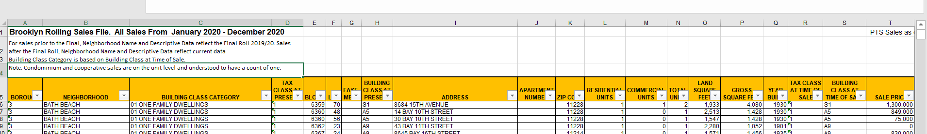

* + - We are going to read the data in with read_xls(), a function in the readxl package
    - The function read_xls takes a number of arguments (the stuff that goes in between the parenthesis)
* path = where on your machine the file is stored
* sheet = the name of the sheet (some excel files have multiple sheets)
* na = what to count as missing value (by default it counts blank cells as missing
* skip = Minimum number of rows to skip before reading anything, be it column names or data. Leading empty rows are automatically skipped, so this is a lower bound. Ignored if range is give
  + - looking at these data it seems that all we need here is to tell it to skip the first 4 line
    - on my computer, I have the data in my working directory in a folder called “datasets.” You will have to change this to wherever you put the data. If you are having trouble PLEASE reach out. Getting a handle on this is one of the biggest hurdles and I am here to help!

brooklyn <- read_xls(path ="datasets/rollingsales_brooklyn.xls", skip = 4)

Note: the ‘path’ is where the data sheet is located on the computer. If you write path = “” and hit the tab key between the quotation marks you should see the files in your current working directory pop up. That will let you choose the file you want

* + We now have the dataset stored as an object called “brooklyn.” To examine it we can just type the function’s name into R

brooklyn

you will see something like this:

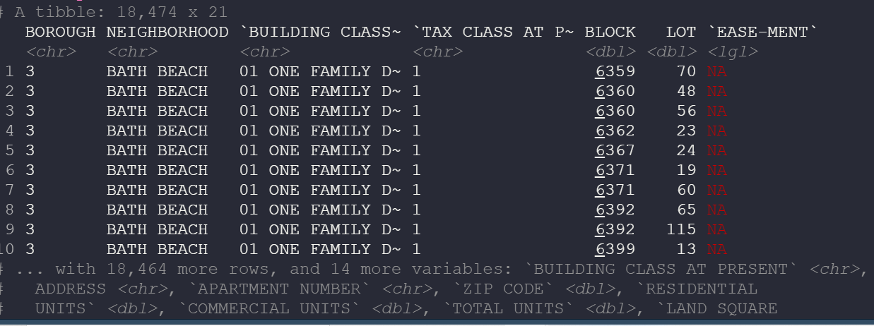

* + Note that it tells us there are 11,874 rows and 21 columns of data…that is a lot of data!
  + It also shows the first few rows and data.
  + Now, enter the following into R to create two new objects that have the same data source but use different *functions* for reading in the data (read.csv and read_csv). Note that this time we are using the .csv file rather than the .xls file

brooklyn_csv_base <- read.csv("datasets/rollingsales_brooklyn_csv.csv", skip = 4)

brooklyn_csv_readr <- read_csv("datasets/rollingsales_brooklyn_csv.csv", skip = 4)

Now compare the three different datasets….what differences do you see in how the data are stored? One way to do this is with the Tidyverse’s glimpse() function, which gives a nice summary of the object. You will notice that with glimpse you can see the name of each column and then the class of that column. Pay attention to each object and when the class of a column is different.

glimpse(brooklyn_csv_base)

glimpse(brooklyn_csv_readr)

glimpse(brooklyn)

jot down some notes about how these objects differ:

Column names are different. The .xls glimpse is far more comprehensible for sure. Lots of “x1, x2, x3….” for the .cvs files.

Step 2: connecting datasets together

Note how each borough is setup the same in the sheets. This is a happy thing for us. Lets say we want to look at all the data at one go!

brooklyn <- read_excel("rollingsales_brooklyn.xls", skip = 4)

bronx <- read_excel("rollingsales_bronx.xls", skip = 4)

manhattan <- read_excel("rollingsales_manhattan.xls", skip = 4)

staten_island <- read_excel("rollingsales_statenisland.xls", skip = 4)

queens <- read_excel("rollingsales_queens.xls", skip = 4)

# Bind all dataframes into one, save as "NYC_property_sales"

NYC_property_sales <- bind_rows(brooklyn, bronx, manhattan, staten_island, queens)

glimpse(NYC_property_sales)

Now we have all the data in one dataset. Note the column “BOROUGH” is a numerical code for the borough so that info is still present. We could rename them if we wanted to…

Step 3: Clean up the data: Let’s circle back to Brooklyn dataset from above

* Take a look at the col names :

colnames(brooklyn)

take a moment and jot down some thoughts about what we might want to fix about the column names

* The titles are long
* spacing

To me, a few things stick out about the names of the columns that may make data analysis tricky

* 1. All capitalized
  2. Spaces in the col names

We can fix this in a number of ways:

* **To get the capitalization fixed:**

Take a look at the function below. A few things are happening here. The “%>%” is a function from the tidyverse that makes coding a bit easier. It is called a pipe and basically it says “then”. So you can read the code as “take the column names from brooklyn then use the str_to_title function. This function, also part of the Tidyverse, take a string (an ordered sequences of characters) and changes the case of the letters. Play around and see what other str_to_ functions exist and what they do

colnames(brooklyn) %>% str_to_title()

* But this code doesn’t change anything. to save this we just assign it to colname(brooklyn)

colnames(brooklyn) <- colnames(brooklyn) %>% str_to_title()

The code you previded wasn’t working for me?? I might have installed a package wrong or something so I did something different but would love you help down the road.

**What I put in:**

library(stringr)

colnames(Brooklyn)<-colnames(Brooklyn, do.NULL = TRUE, prefix = "col")

print(str_to_title(colnames(Brooklyn)))

**What I got**:

[1] "Borough" "Neighborhood"

[3] "Building Class Category" "Tax Class At Present"

[5] "Block" "Lot"

[7] "Ease-Ment" "Building Class At Present"

[9] "Address" "Apartment Number"

[11] "Zip Code" "Residential Units"

[13] "Commercial Units" "Total Units"

[15] "Land Square Feet" "Gross Square Feet"

[17] "Year Built" "Tax Class At Time Of Sale"

[19] "Building Class At Time Of Sale" "Sale Price"

[21] "Sale Date"

**Now, we want to remove the spaces**

Thankfully Tidyverse gives us that with the useful str_replace_all() function, Here, the str_replace_all() takes two arguments. The first one is what we want to replace and the second it what we want to put in its place.

colnames(brooklyn) %>% str_replace_all(" ", "_")

In this instance, we are replacing a space with a underscore. How would you replace the space with it with a . ?

Remember to save it:

colnames(brooklyn) <- colnames(brooklyn) %>% str_replace_all(" ", "_")

Worked like a charm!!

fun fact: you could do this all in a single line like this: colnames(Brooklyn) <- colnames(brooklyn) %>% str_to_title() %>% str_replace_all(" ", "_")

**Protip:**

Now that you did that I’m going to teach you a trick using the janitor package we installed at the beginning. In that package is a function called clean_names() which will change the case and remove spaces in one go!

brooklyn %>% clean_names()

what do I put in the parentheses? “colname(Brooklyn)”??

***tried it and R said “ could not find function "%>%"”

# Part 3: Try it on your dataset

Take a look at the data you are examining for this course. Thinking about what we talked about this week and in this lab, is there anything in your dataset that needs to be ‘cleaned' so that it can work well. If so, what steps might you think about here

* For one thing the “national names” document has 1048576 rows of information so maybe I would limit it to the top ten names of every year
* The names are categorized as “f” or “m” in one column to denote sex, maybe I could make a male column and a female column then have “yes” and “no”?

# Part 4: assessment

1. How can you apply ‘clean’ spreadsheet techniques to other work you do?

One thing is for sure, I know how to think more critically about creating tables in the first place!! I did a geology project a year ago that required making many tables, and this assignment has made me realised a lot of my troubles were self inflicted.

1. After doing this lab, what sorts of reasons might you give for the importance of good data organization?

You avoid losing data, data is easier to search, information is easier to read, it allows variables to remain connected/related.

1. “Reading in” data to R, especially *messy* data, is one of the most frustrating parts of data analysis. Do you think you are getting the hang of it? What could make this easier?

I think I am getting a better understanding. When I ran into a road block I was able to solve it (so far). Personally my main problem has been with the packages and I’m unsure why. It probably has to do with me installing them improperly

1. Next week we are starting to think about data visualization. For your dataset what sorts of figures might you want to make?